- \Operation\Tube blow out\Setting
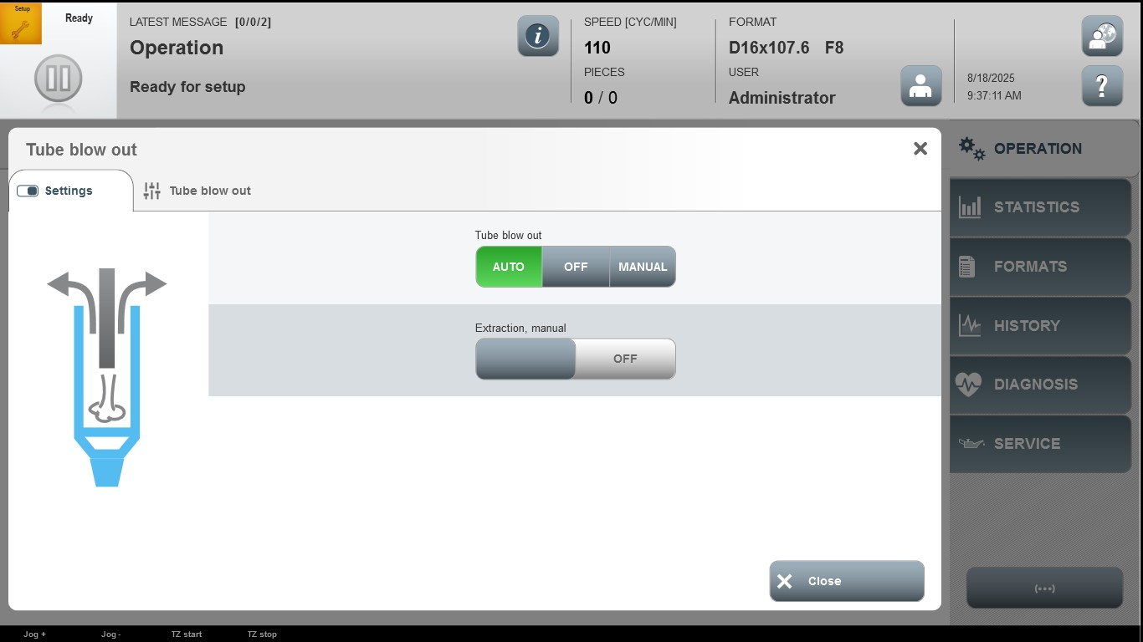

Acceptance criterion | Limits | Pass / Fail: Dev-No. | Date | Initials
Screen matches screenshot | N / A

